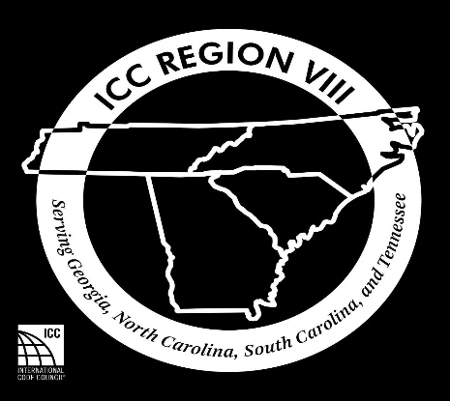

Quarterly Training Registration

Changes to the 2020 National Electrical Code
Greenville, SC 9/11-9/12/20

Name of Attendee(s):________________________________
__________________________________________________
Organization:_______________________________________
Telephone:__________________
Email:______________________________________________
Fee: 65.00
Number of Attendees: _______
X $65.00
Total amount Enclosed: $______
Mail completed application and check to:
CC REGION VIII
c/o Ringo McCollum
75 Archie’s Way
Cleveland, GA 30528

