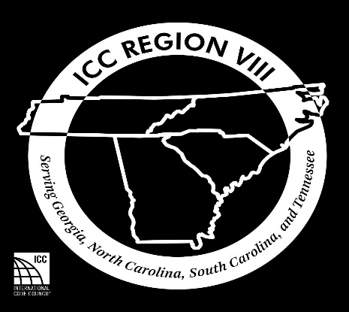

Quarterly Training Registration

June 2022, Helen, GA

Name of Attendee(s):________________________________
__________________________________________________
Organization:_______________________________________
Telephone:__________________
Email:______________________________________________
Fee: 65.00
Number of Attendees: _______
X $65.00
Total amount Enclosed: $______
Mail completed application and check to:
CC REGION VIII
c/o Ringo McCollum
75 Archie’s Way
Cleveland, GA 30528

